UNIT TESTING:

CREATE OPERATION: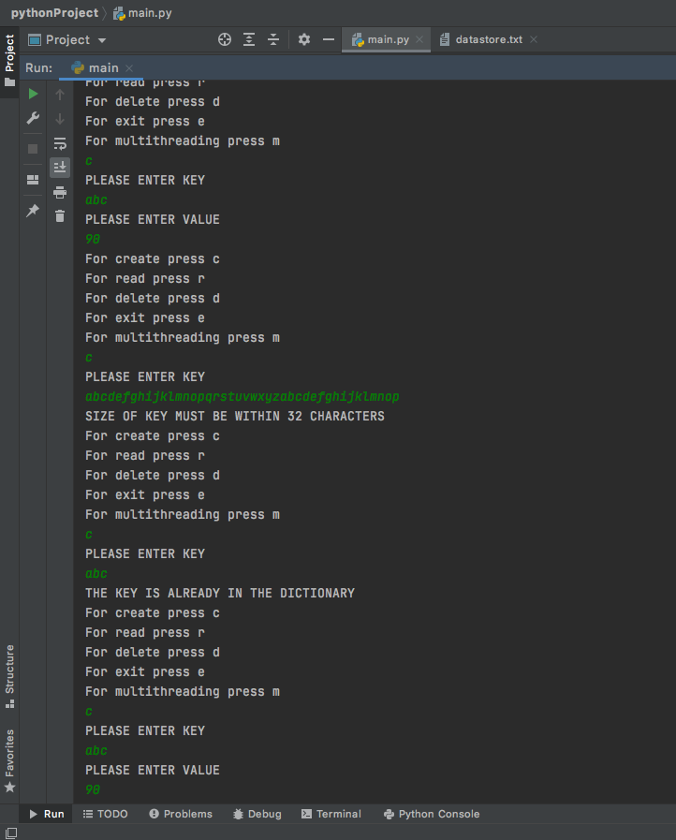

FILE AFTER THE ABOVE OPERATIONS:

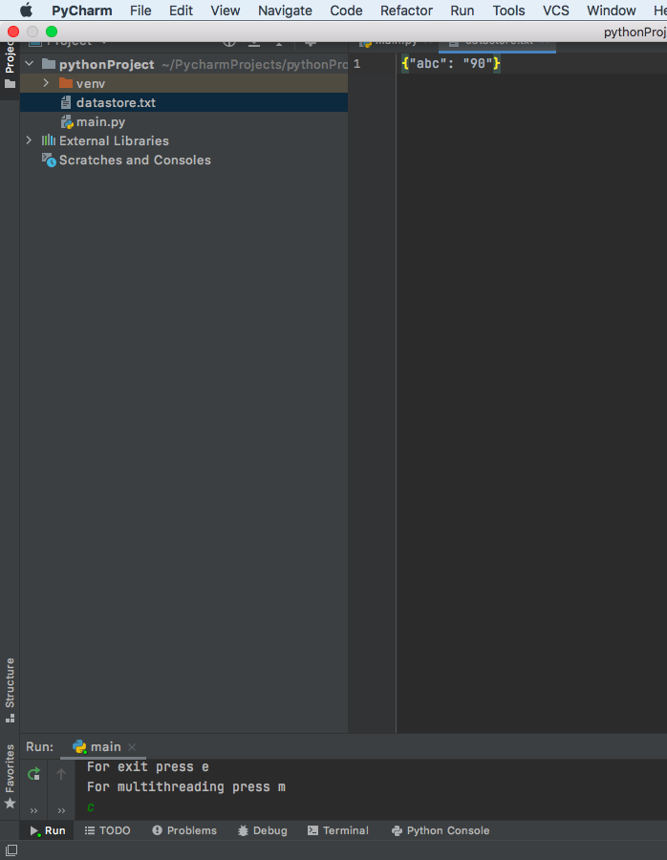

READ OPERATION:

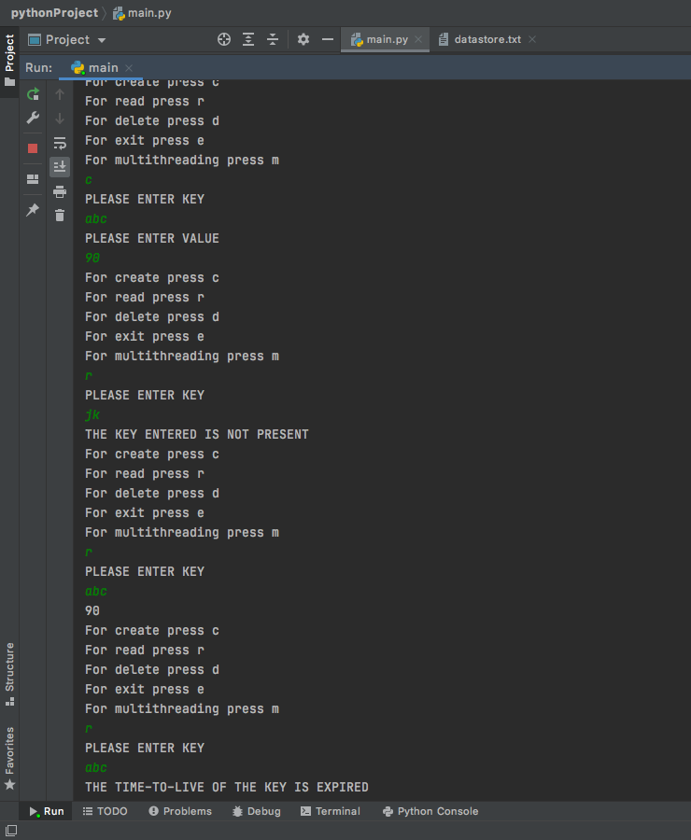

FILE AFTER READ OPERATIONS:

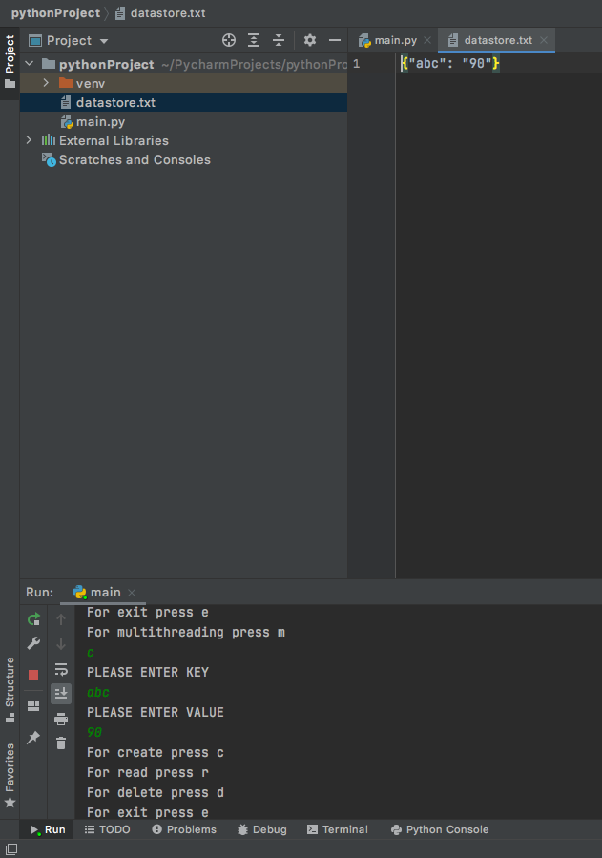

DELETE OPERATIONS:

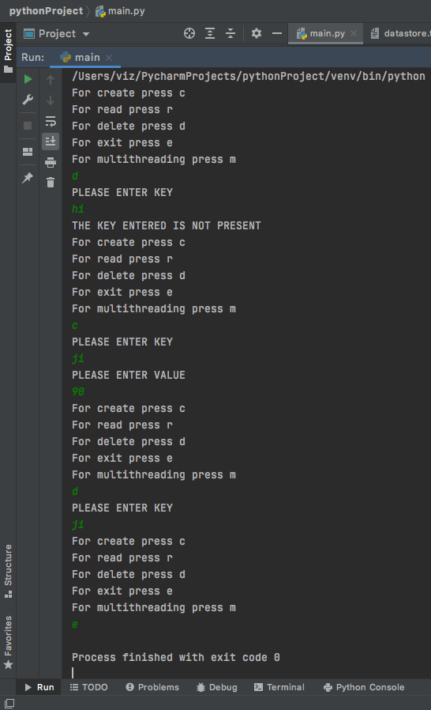

FILE AFTER THE ABOVE OPERATIONS:

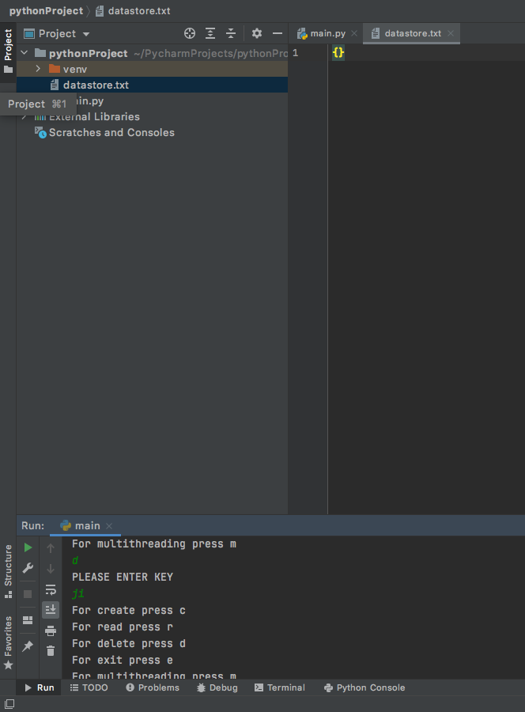

MULTITHREADING OPERATIONS: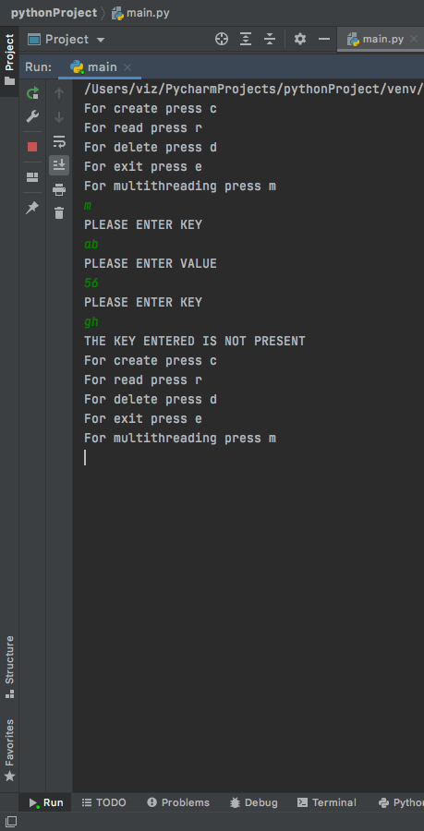

FILE AFTER T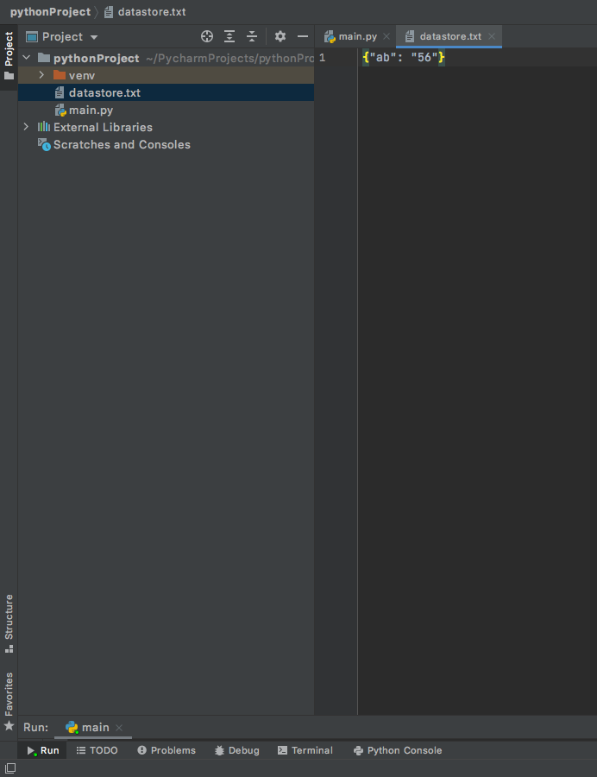HE OPERATIONS: